# **Lab 24: Redux | Actions and Reducer**

## Objectives

*  Define action types
*  Create action creator functions
*  Implement a reducer
*  Configure the project reducer and state

## Steps

### Define action types

1. **Create** the **directory** src\projects\state.
2. **Create** the **file** src\projects\state\projectTypes.js.
3. **Define** the **project** actions types.

#### src\projects\state\projectTypes.js

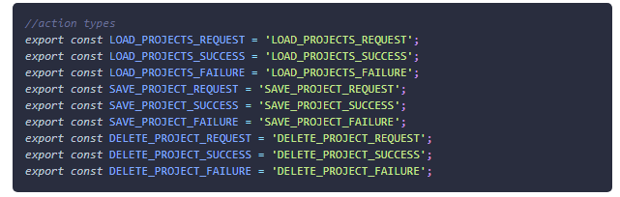

### Create action creator functions

1. **Create** the **file** src\projects\state\projectActions.js.
2. **Define** your **action** **creator** functions and return a ThunkAction (function) instead of just an Action (object) to handle the asyncronous nature of the HTTP calls happening.

#### src\projects\state\projectActions.js

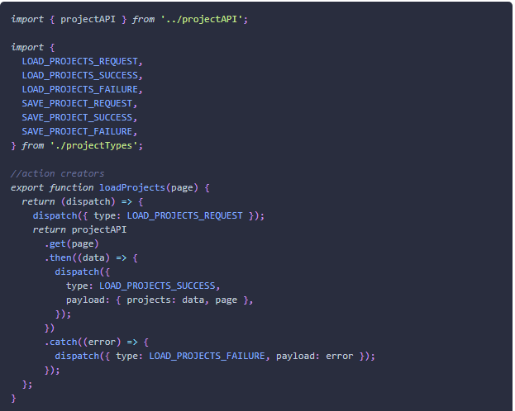

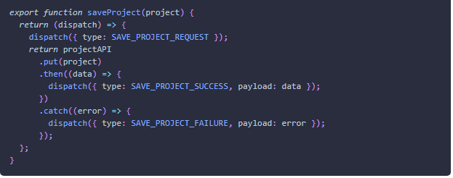

### Implement a reducer

1. **Create** the **file** src\projects\state\projectReducer.js.
2. **Define** your **reducer** function. src\projects\state\projectReducer.js

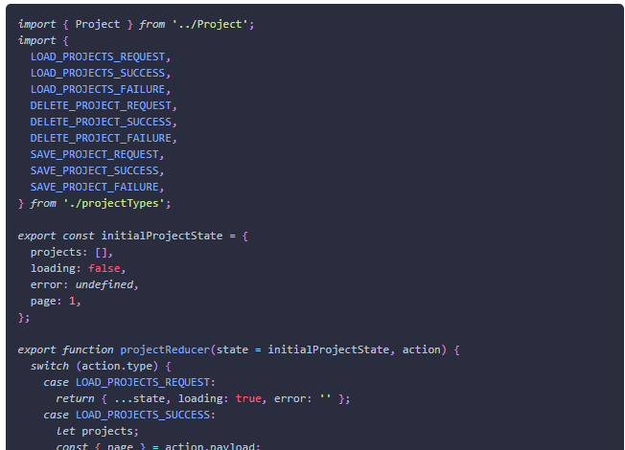

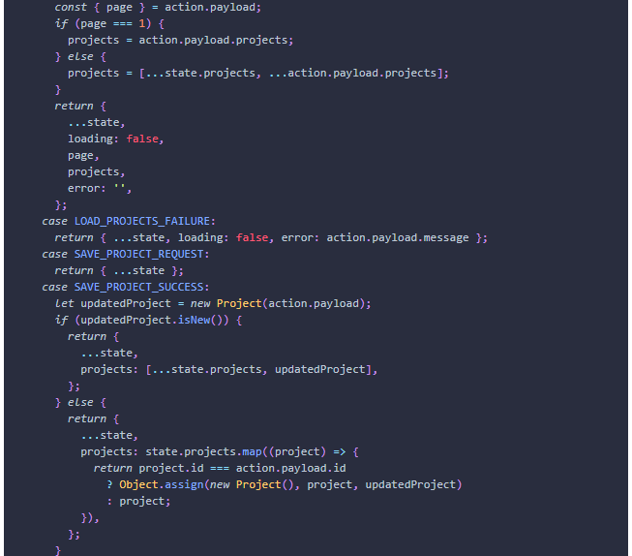

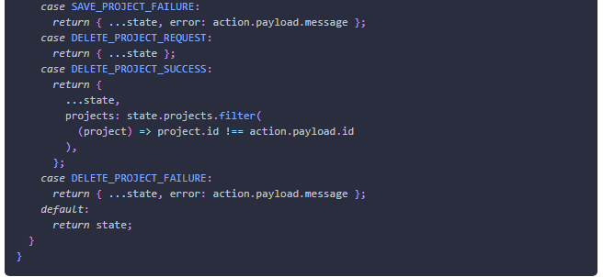

### Configure the project reducer and state

* update state.js

1. **Open** the **file** src\state.js.
2. **Configure** the projectReducer and ProjectState.

#### src\state.js

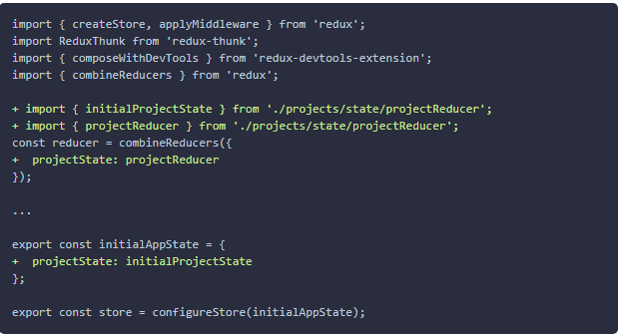

1. **Verify** the application **compiles**.

In the next lab we will connect our Redux code to our React application.

### ✔ You have completed Lab 24